**Anisotropy for Three Canadian Wells by 1-Parameter Inversion**

**Table of Contents**  
1. Theoretical Introduction   
1.1 The Basics  
1.2 Some Possible Workflow  
1.2.1 No fixed parameters in Equinor anisotropy model (three free parameters: a, b, and c)  
1.2.2 One fixed parameter in Equinor anisotropy model (two free parameters: a and b)  
1.2.3 Two fixed parameters in Equinor anisotropy model (one free parameter: a)  
1.3 Final Workflow – 1-Parameter Inversion  
  
2. Checking two assumptions and selecting basic logs and zones   
2.1 General considerations  
2.2 VCLDRY or VSHDRY  
  
3. Effective Mud Properties   
3.1 Consistency in mud properties for fixed formations  
3.2 Effective mud properties for fixed formations  
3.3 Visual verification of mud properties  
  
4. Parameters in Equinor anisotropy model with uncertainties  
4.1 Estimate of the Equinor anisotropy model parameter a from the 1-parameter inversion  
4.2 Uncertainties in the parameters of the Equinor anisotropy model  
  
5 Thomsen’s anisotropy parameters gamma, delta, and epsilon  
5.1 Relative uncertainties in Thomsen’s parameters gamma, delta, and epsilon  
5.2 Visual display of logs representing Thomsen’s anisotropy parameters  
  
6. Summary  
  
7. Acknowledgements  
  
8. References  
  
A. Appendix A – Geolog Python Program listing

**1. Theoretical Introduction**

**1.1 The Basics**

The acronym TFUR in this report is short for the report Trond Anders Seland and Oddmund Rise, «Technology first use report Elastic anisotropy from well logs» - see reference [5] in section 7. All references to equation numbers in this section are equations in this reference.  
  
A basic assumption of this report is the assumption that the Thomsen anisotropy parameter gamma is identical to zero in sand. Additional assumptions are the four assumptions about equation (8) in TFUR page 15:  
 A1. The well is vertical  
 A2. The frequency limit is zero  
 A3. No permeability effects  
 A4. No near wellbore alternation effects

Based on these 5 assumptions we have result Result1 below - relating Stoneley shear slowness DTST to shear DTS, bulk density , mud density , and compressional mud sonic DTm - by inserting equations (7) and (8) into equation (6) in TFUR:

|  |
| --- |
| **Result1. If the Thomsen gamma anisotropy parameter gamma is zero in sand and if the assumptions for equation (8) in TFUR are valid, then the following equation is valid in pure sand:** |

By plotting vs. , we should then get a linear graph whose gradient is the mud density and whose intercept with the second axis is the mud slowness squared - see section 3.2 for the results on the graphs for the current wells. In this theory section the statistical estimated values for and will be denoted resp. and .

Recall now the Equinor anisotropy model (details in references [1], [2], and [4]) for the Thomsen anisotropy quantities , , and (defined in reference [6]) are given by equations (1) – (3) in TFUR as   
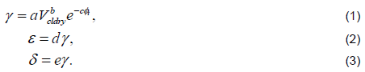  
with default parameter values  
  
  
Note that in the limit , then the Equinor anisotropy model implies that , and . In particular, the Equinor model is therefore consistent with the basic assumption that Thomsen gamma is zero in sand. For consistency we also need . Further, we should expect the parameters a, b, c > 0.

Based on the Equinor anisotropy model, we have the result Result2 below by combining equations (1), (6), (7) and (8) in TFUR:

**Result2. If the Thomsen anisotropy parameter gamma follows the Equinor anisotropy model in shale and if the assumptions for equation (8) in TFUR are fulfilled, then the following equation is valid in shale:**

Note that the formula in Result1 follows from the formula in Result2 in the limit , assuming b > 0.

**1.2 Some Possible Workflows**

There are in principle three different approaches for estimating the parameters in the Equinor anisotropy model, depending on how many independent variables one wants to vary.

**1.2.1 No fixed parameters in Equinor anisotropy model (three free parameters: a, b, and c)**  
In principle, it is possible to use the Result2 equation to make a multilinear regression with respect to the independent variables Ln(VCLDRY) and porosity :

, where we should expect   
  
However, it is our experience that the large-scale behavior determined by the parameter c is not very stable on a typical formation thickness scale: The average porosity in shale typically decreases 1.5 PU every 100 m in overburden Tang-Lange on Haltenbanken [7]. Since the wells considered in this report are much deeper, the change in average porosity is even smaller.  
  
**1.2.2 One fixed parameter in Equinor anisotropy model (two free parameters: a and b)**

A better and more realistic attempt is to assume the default value c = 4.5 and do a linear regression on the variable Ln(VCLDRY):

, where we should expect

Another approach is to do an optimalization formulation where we search for a minimalization of the root mean square (RMS) of the difference between LFP_GAMMA_SIMP and a generic gamma vector constrained by Equinor anisotropy model:

, where we should expect

**1.2.3 Two fixed parameters in Equinor anisotropy model (one free parameter: a)**

The third and simplest approach is to vary only one parameter, parameter a, in the Equinor model.   
Since we have no variable to vary in a regression, the best solution seems to make an inversion:

, where we should expect   
  
**1.3 Final Workflow – 1-Parameter Inversion**

In accordance with the principle of choosing the simplest explanation if several explanations[1] are possible, we will use the 1-parameter inversion approach in section 1.2.3 as our main workflow. In Figure 1.3-1 we see this inversion done for formation BVT_3 in well G-92 where the plot of RMS vs. the free parameter looks like a hockey stick.  
  
The 2-parameter inversion and the 1-parameter regression in section 1.2.2 will later be used to estimate the uncertainty in the parameters a and b in the Equinor anisotropy model by comparing its result to our base case – the result of the 1-parameter inversion. The analysis is done in section 4.  
  
The Python program used in Geolog to do these two inversions are given in Appendix A.   
  
  
Figure 1.3-1 Example of 1-parameter inversion in formation BVT_3 in well G-92.  
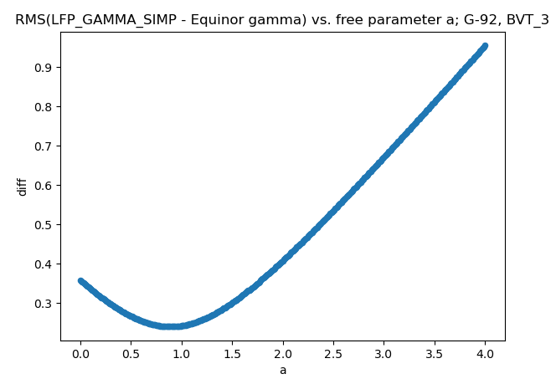

**2. Checking two assumptions and selecting basic logs and zones**  
**2.1 General considerations**

For the wells CA CAMBRIOL G-92, CA CAPPAHAYDEN K-67, and CA CAPPAHAYDEN K-67Z the location of Stoneley log DTST is given in column 2 of table Table 2-1.

In the third column is the zone (in m MD RKB) that is covered by the Stoneley log.

In the fourth column is a test of assumption A4 in section 1.1. Formations are chosen based on two main criteria: There should be a sand package and no close change in bit size. The chosen formations are given in table Table 2-2.

The last column in table Table 2-1 shows the span of the inclination angle INC in the range of the Stoneley log DTST. Figure 2-1 shows the graph of INC vs. TVDML in the complete zone of the LFP interpretation. As a heuristic rule, sonic artefacts will appear if the sum of the inclination angle and the formation dip angle become larger than 30 degrees. From Figure 2-1 we observe that the bedding angle must be more than 20 degrees in order for this hand-waiving rule to kick in. On the other hand, K-67Z has inclination angle close to 30 degrees and K-67 has inclination angle close to 20 degrees. Thus K-67 and K-67Z are much more likely to give sonic artefacts than G-92. Since there is an difference of 10 degrees between K-67 and K-67Z, it might be difficult to obtain a common set of anisotropy values.  
  
Table 2-1. Basic data used in the anisotropy study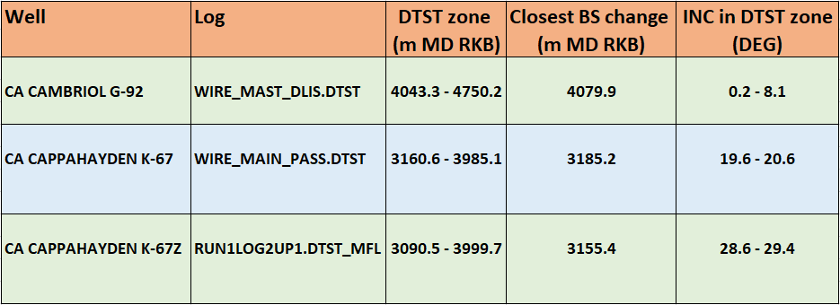

Table 2-2. Relevant formations for the various wells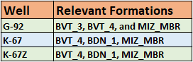Figure 2-1. Deviation angle of wells as a function of TVDML in the range of LFP interpretation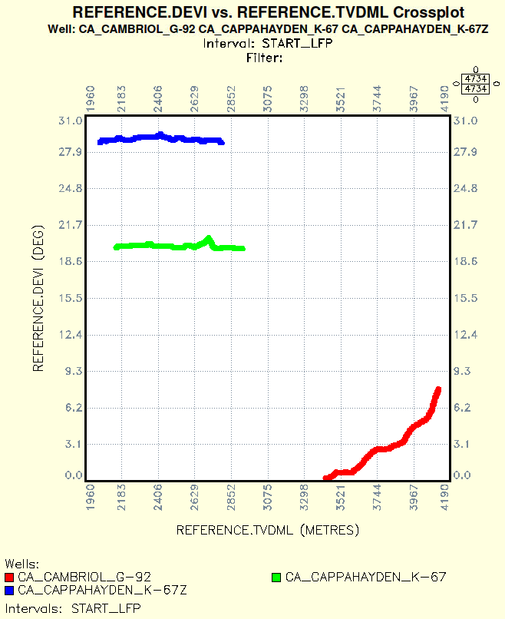

**2.2 VCLDRY or VSHDRY**

The recommended way to estimate the clay content LFP_VCLDRY is to use the La Vigne model [3] where the edited neutron density log LFP_NPHI_EDIT together with the total porosity LFP_PHIT give the result

, where default values of sandstone correction SSC = 0.05, hydrogen index HI = 1.0, and the neutron porosity for clay mineral VNCL = 0.5 have been used. In our case, we have assumed LFP_NPHI_EDIT = LFP_NPHI.  
  
An alternative way (not used in this study) would be to use a scaled LFP_VSHDRY where a typical global scaling factor is 0.6.

**3. Effective Mud Properties**

**3.1 Consistency in sand properties for fixed formation as a function of well path**

Using Result1, we see from figures Figure 3.1-1 and Figure 3.1-2 that the wells K-67 and K-67Z have a similar trend that are clearly different from the trend of G-92. In the next section we will consider the possibility of handling K-67 and K-67Z together.  
  
Figure 3.1-1. Comparing sand properties for a fixed formation in all wells G-92, K-67 and K-67Z

|  |  |
| --- | --- |
| **FM = BVT_4** | **FM = MIZ_MBR** |
|  |  |

Figure 3.1-2. Comparing sand properies for a fixed formations in maximum two wells

|  |  |
| --- | --- |
| **FM = BDN_1** | **FM = BVT_3** |
|  |  |

**3.2 Effective mud properties for various formations**

Based on the results in section 1.1, we initially for each formation split the three wells in two groups – K-67 and K-67Z in one group and G-92 in the second group. We found that the results were suboptimal, especially for formation BVT_4. Since the inclination angle is quite different for K-67 and K-67Z, we think it is reasonable to split these two wells in the further analysis.

Based on the results of sand calibrations in figures Figure 3.2-1 – Figure 3.2-4, we get the effective fluid properties in Table 3.2-1. Since we are estimating two quantities based on a theoretical relation, we have used regressions of RMA type.

Table 3.2-1. Final effective mud properties based on sand calibration; RMA regression  
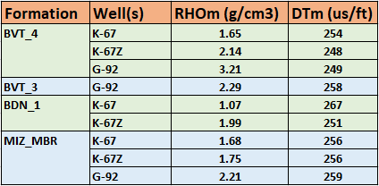

The effective mud slownesses are remarkable close for G-92, K-67, and K-67Z. The main uncertainty is in the effective mud density. For G-92 it is the density in BVT_4 for well G-92 that gives rise to the large value in RHOm and might be an outlier.   
Figure 3.2-1. Effective mud properties for BVT_4

|  |  |
| --- | --- |
| **FM = BVT_4; Wells = K-67** | **FM = BVT_4;Well = K-67Z** |
|  |  |

|  |
| --- |
| **FM = BVT_4; Wells = G-92** |
|  |

Figure 3.2-2. Effective mud properties for MIZ_MBR

|  |  |
| --- | --- |
| **FM = MIZ_MBR; Wells = K-67** | **FM = MIZ_MBR; Well = K-67Z** |
|  |  |

|  |
| --- |
| **FM = MIZ_MBR; Wells = G-92** |
|  |

Figure 3.2-3. Effective mud properties for BDN_1

|  |  |
| --- | --- |
| **FM = BDN_1; Wells = K-67** | **FM = BDN_1; Wells = K67Z** |
|  |  |

Figure 3.2-4. Effective mud properties for BVT_3

|  |
| --- |
| **FM = BVT_3; Wells = G-92** |
|  |

**3.3 Visual verification of mud properties**

In this section we are using the plotting layout at the end of section 8.4.4 on page 16 of TFUR, i. e., using the Geolog Xplot “lfp_dts_hor_vs_dts_vert.xplot” to verify the sand vs. shale splitting. The results are shown in figures Figure 3.3-1 – Figure 3.3-6. We believe all these splittings are either good or very good. In particular, the splitting for well G-92 is very good for all relevant formations.

Figure 3.3-1 Validation of mud properties in formation BVT_4 in well = G-92  
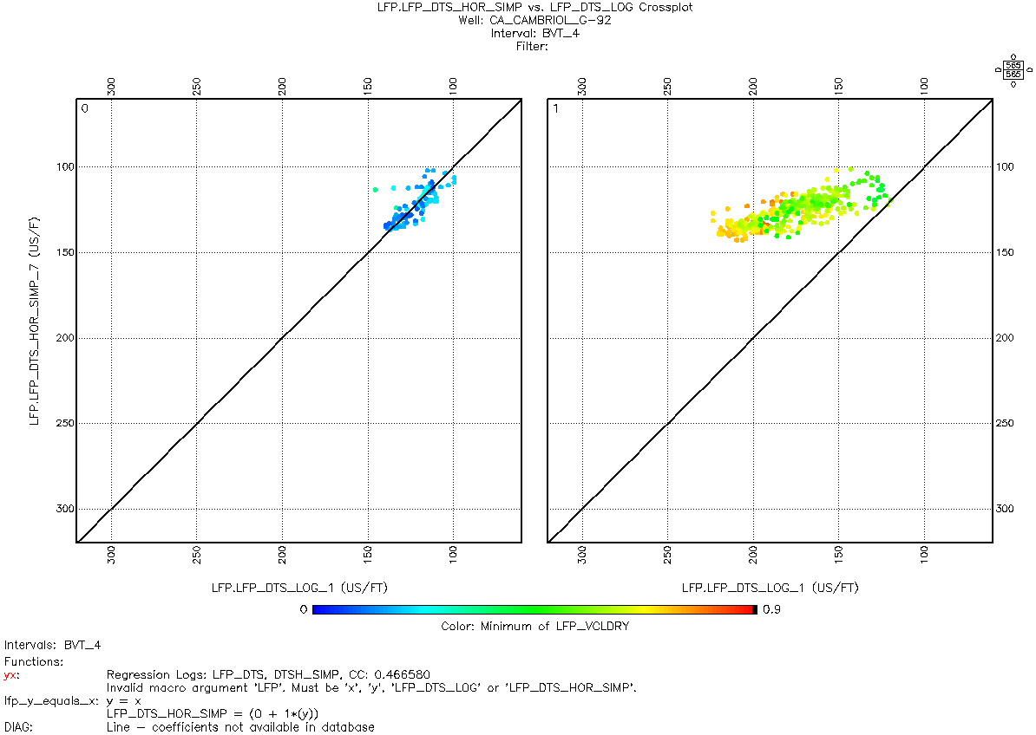  
  
  
Figure 3.3-2 Validation of mud properties in formation BVT-3 in well G-92  
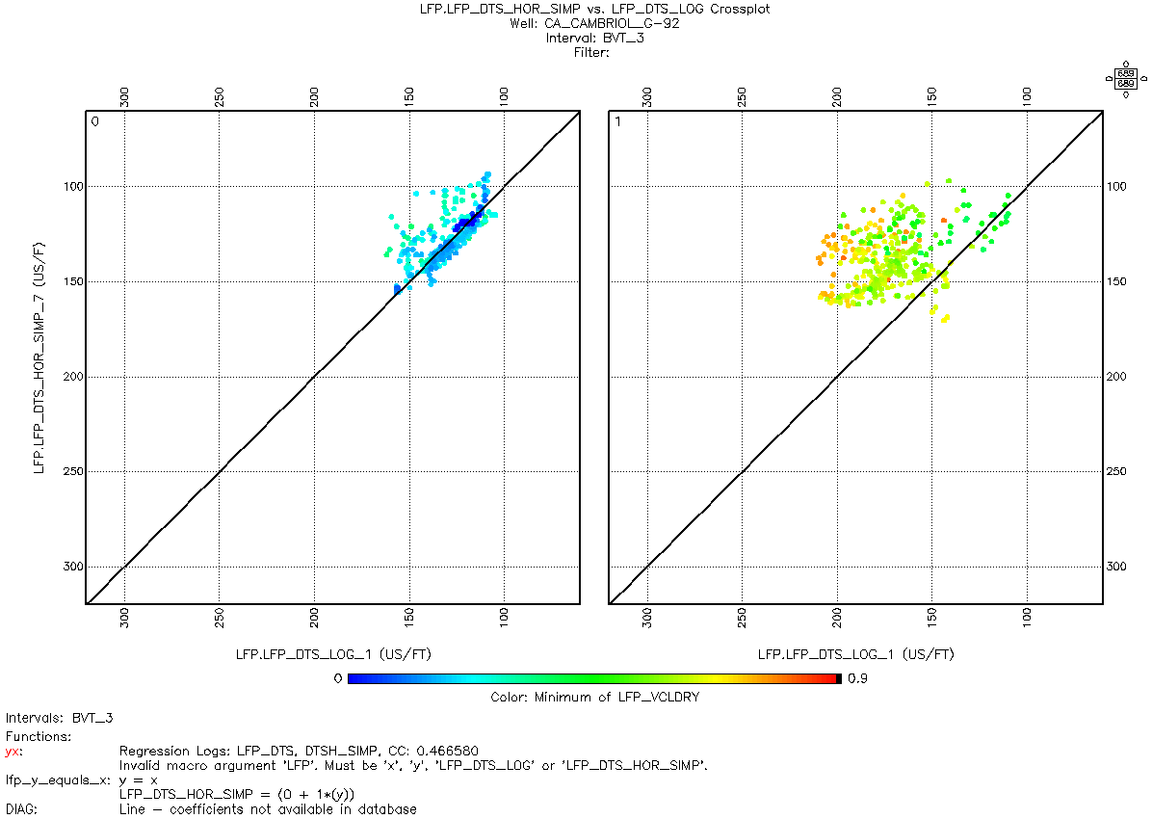

Figure 3.3-3 Validation of mud properties in formation MIZ_MBR in well G-92  
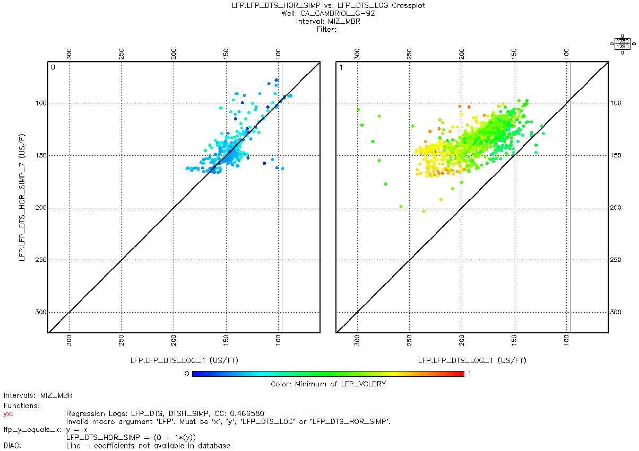

Figure 3.3-4 Validation of mud properties in formation BVT-4 in wells K-67  
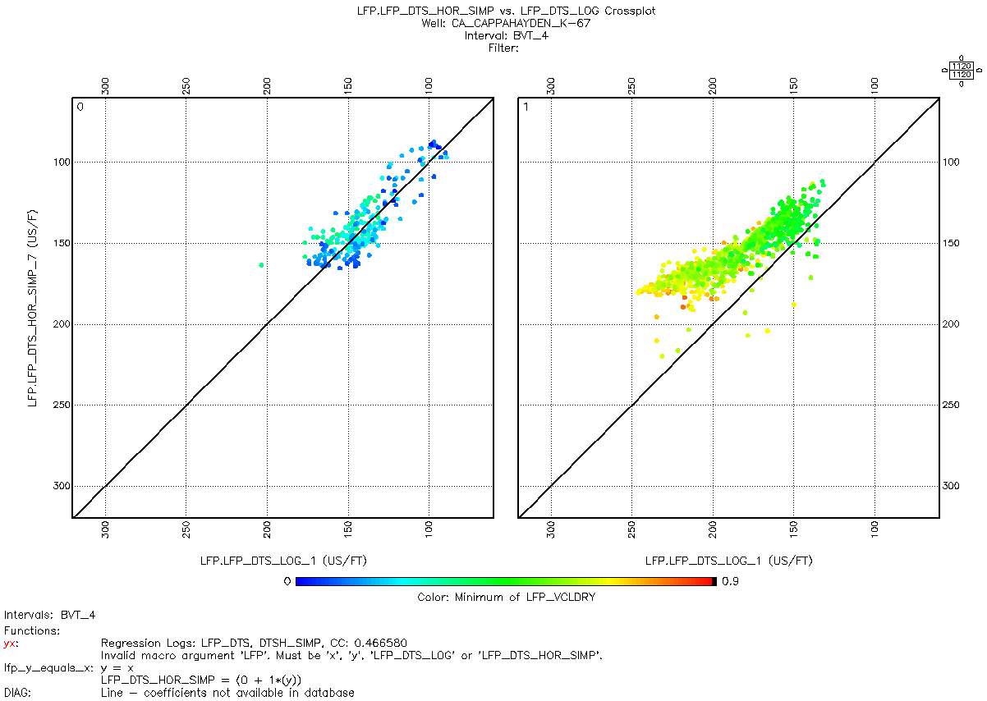  
  
  
  
  
  
  
Figure 3.3-5 Validation of mud properties in formation BDN_1 in wells K-67  
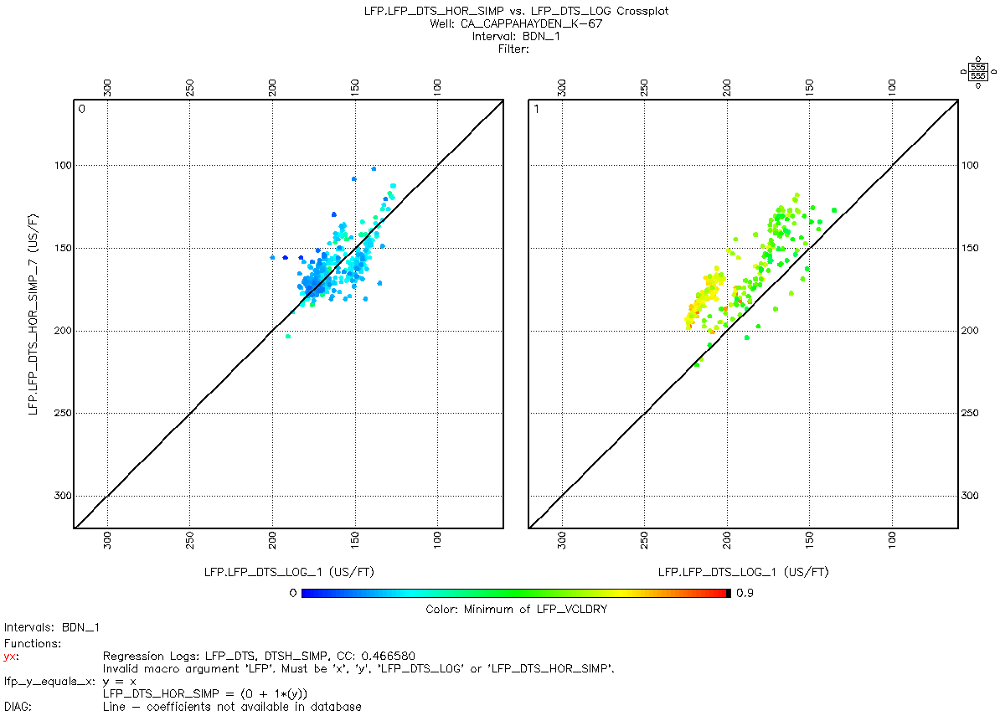  
  
Figure 3.3-6 Validation of mud properties in formation MIZ_MBR in wells K-67  
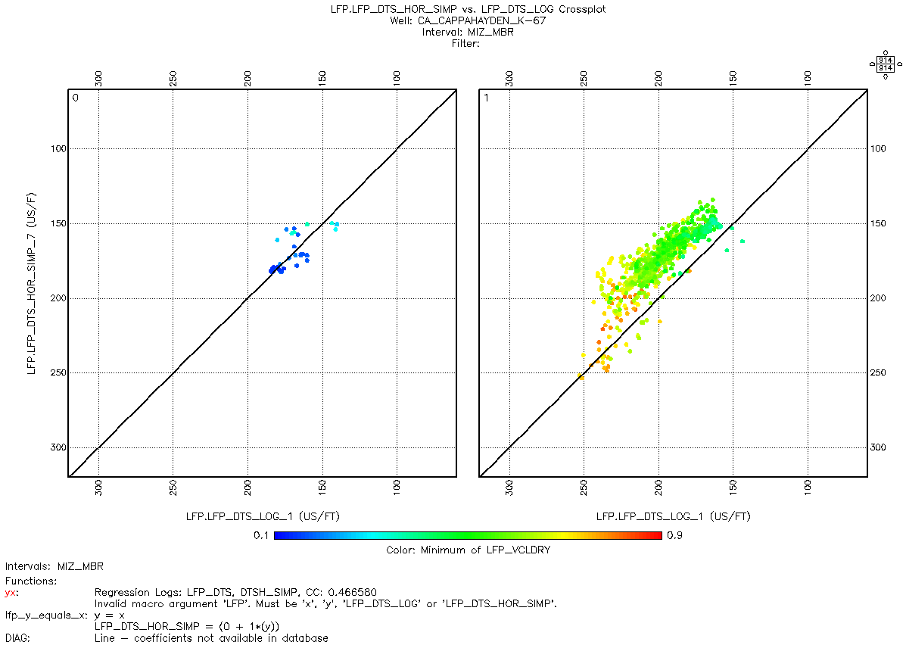  
  
  
Figure 3.3-7 Validation of mud properties in formation BVT_4 in well K-67Z  
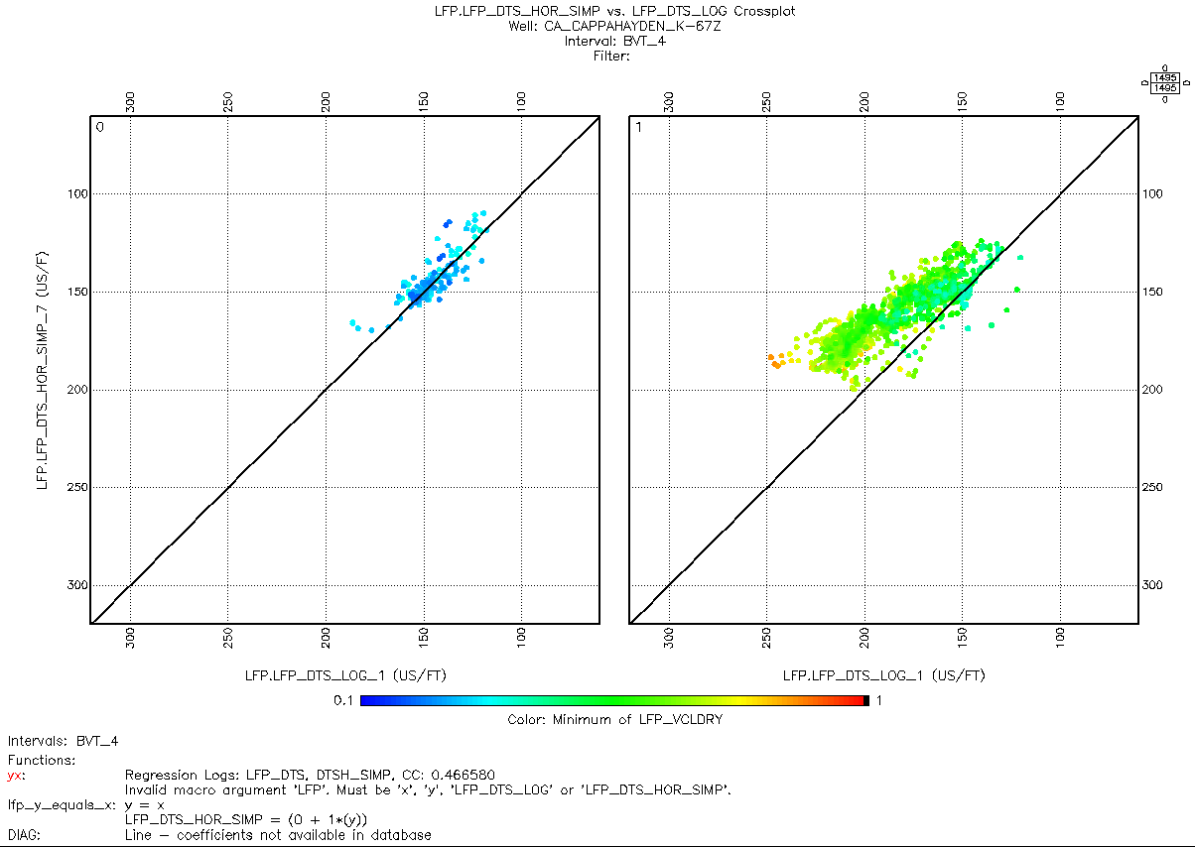

Figure 3.3-8 Validation of mud properties in formation BDN_1 in well K-67Z  
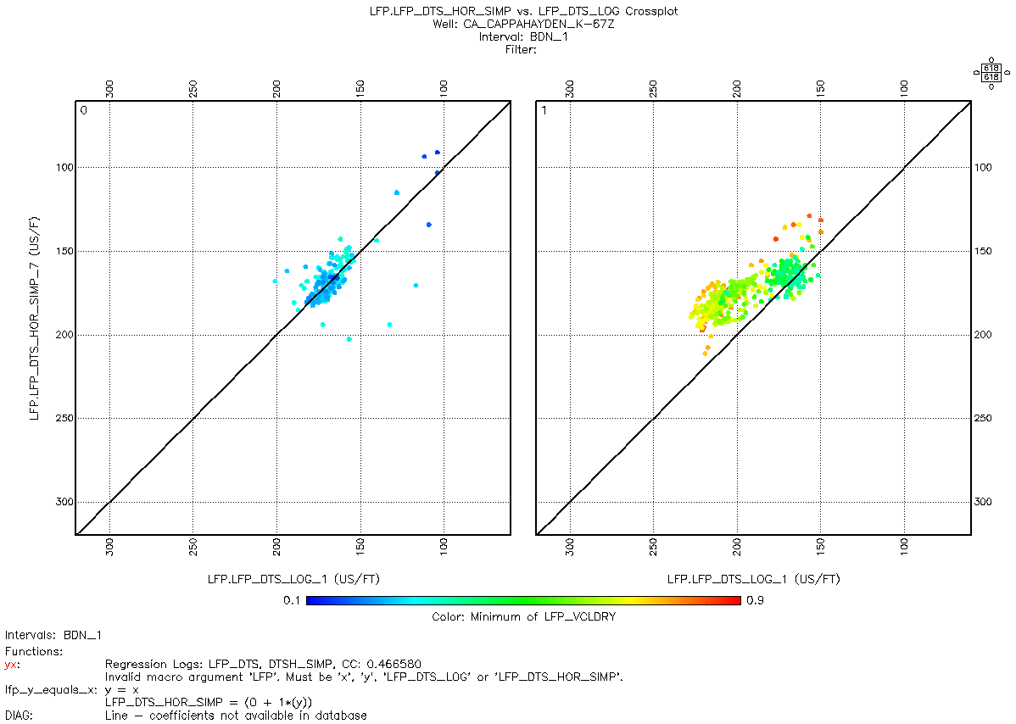

Figure 3.3-9 Validation of mud properties in formation MIZ_MBR in well K-67Z  
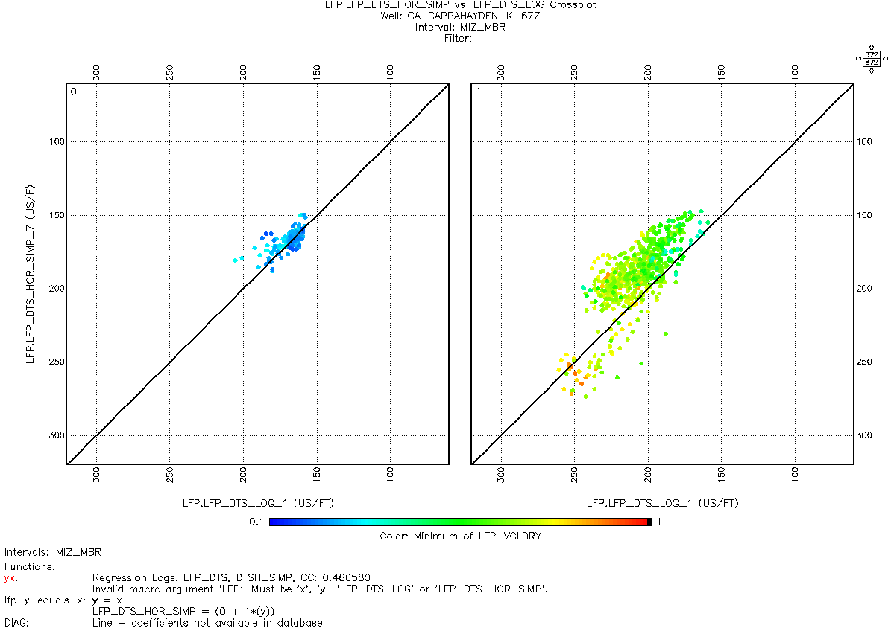

**4. Parameters in Equinor anisotropy model with uncertainties**

**4.1 Estimate of the Equinor anisotropy model parameter a from the 1-parameter inversion**  
Assuming the mud properties in section 3.2, the parameter a was determined by 1- parameter inversion (section 1.2.3, our base case) and by 2-parameter regression (section 1.2.2). For the remaining parameters, the default values have been used.  
  
Table 4.1-1. Parameter a in Equinor anisotropy model by 1-parameter inversion  
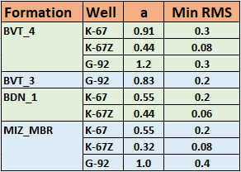  
  
**4.2 Uncertainties in the parameter a of the Equinor anisotropy model**We will make use of the 2-parameter inversion to argue that the typical relative uncertainty in a is typically on the order of magnitude 20% - 30%.  
   
Using the 2-parameter inversion code in Appendix A in BVT_3 in well G-92 leads to a = 1.26 and b = 2.16. Defining the uncertainty of a and b to be half the difference between the 2-parameter case and the 1-parameter case (where b = 1.5 by default), we get the uncertainty estimates and .

**5 Thomsen’s anisotropy parameters gamma, delta, and epsilon**  
**5.1 Relative uncertainties in Thomsen’s parameters gamma, delta and epsilon**  
A logarithmic differentiation of the gamma function in the Equinor anisotropy model with respect to the parameters a, b, and c gives to first order the relative uncertainty . Since we have used a fixed c, it is consistent to assume .

Using the top shale (4623.3 m MD RKB – 4667.3 m MD RKB) in BVT_3 of G-92 with average VCLDRY equal to 0.63, we get finally the following estimate for the relative uncertainty of gamma:

Since the Thomsen epsilon and delta values in the Equinor model are a constant multiplied with the gamma value, they will have the same relative error. Thus, if the Equinor anisotropy model is true, then all the Thomsen anisotropy parameters have a relative uncertainty of about 40%.

**5.2 Visual display of logs representing Thomsen’s anisotropy parameters**

Based on the Equinor parameters determined by the 1-parameter inversion in the previous section, we may display visually the logs corresponding to the Thomsen’s anisotropy parameters gamma, delta, and epsilon. The result for each well is shown in Figure 5.2-1 – Figure 5.2-3 where the gamma log (red) and the LFP_GAMMA_SIMP log (cyan) have scale 0.0 – 1.5, the delta log (blue) has scale 0.0 – 0.3, and the epsilon log (brown) has scale 0.0 – 0.6.  
  
Figure 5.2-1. Thomsen parameters for G-92  
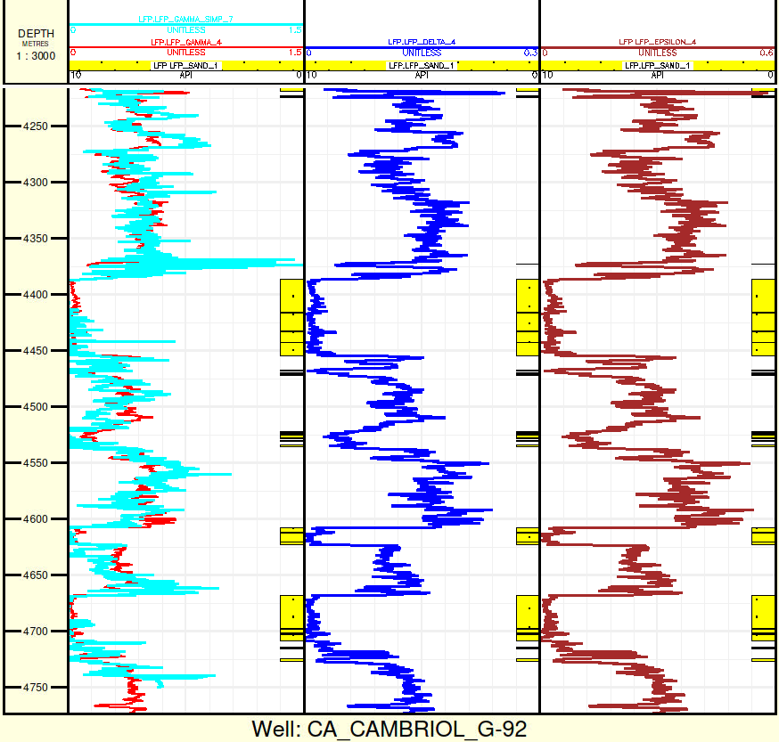  
  
  
Figure 5.2-2. Thomsen parameters for K-67  
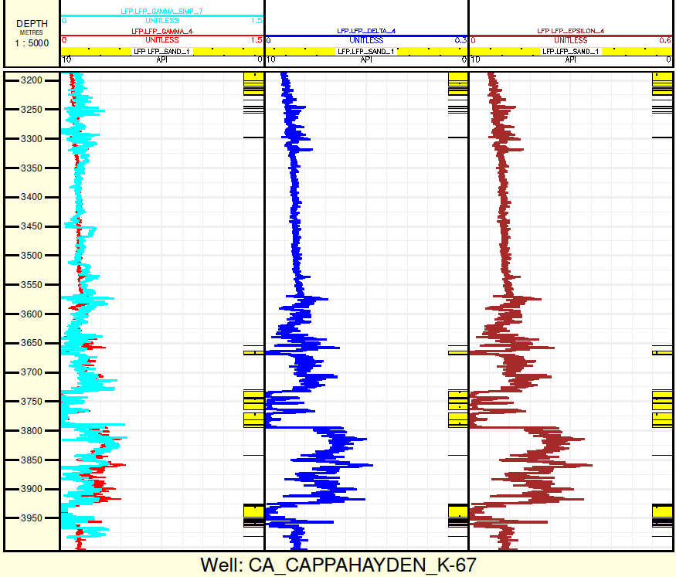  
  
Figure 5.3-3. Thomsen parameters for K-67Z  
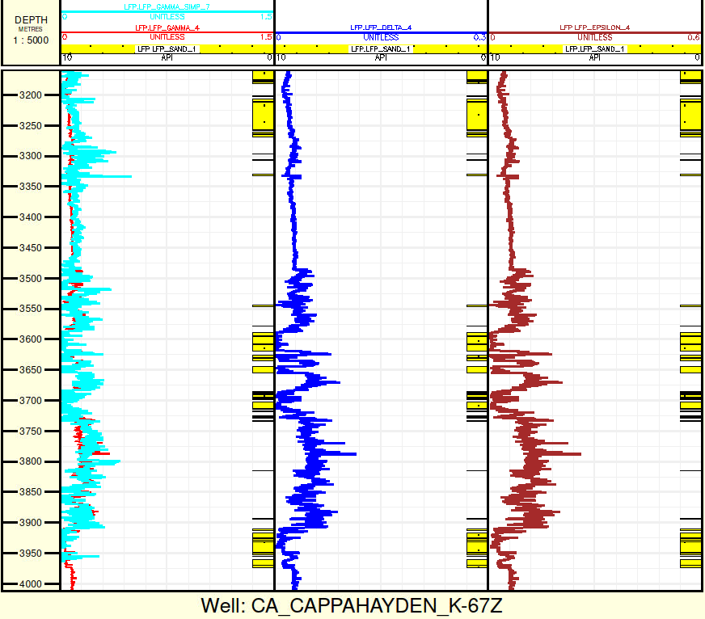

**6. Summary**

By demanding the Thomsen gamma anisotropy parameter to be zero in sand, we have used the equation in Result1 in section 1.1 to determine the effective mud properties given in Table 3.2-1. The consistency of these properties was visually verified by a sand-shale splitting in section 3.3.

The parameter a in the Equinor anisotropy model was determined in Table 4.1-1 by the 1-parameter inversion method in section 1.2.3. Further, the uncertainty in a was estimated to be 0.22 using the 2-parameter inversion in section 4.2. Based on this estimate, the Thomsen parameter gamma was determined to have 40% relative uncertainty in section 5.1. By design of the Equinor anisotropy model, the relative uncertainties of Thomsen delta and epsilon must then be 40% as well.

Finally, in section 5.2 the resulting Thomsen anisotropy logs were displayed for all three wells.

**7. Acknowledgements**  
Thanks to Trond Anders (trse) and Hans Petter (hanspn) for comments to an early draft of this report. Also thanks to Christian (chh) for discussions on VCLDRY.

**8. References**  
[1] Brevik, I. et al. (2010),  
“A workflow for velocity model building using rock physics and rock mechanics”,   
Statoil report 20100920.  
  
[2] Duffaut, K. et al. (2012),   
“Modelling Elastic and Electric Anisotropy in Sedimentary Rocks”,   
Statoil report 20111231.  
  
[3] La Vigne, J. et al. (1994),  
“Density-Neutron Interpretation in Shaly Sands”,  
SPWLA 35th Ann. Logging Symp., June 19 – 22, paper EEE (16 pages)  
  
[4] Renli, L. et al. (2013),   
“Elastic anisotropy estimation from log data”,   
2012 status report, Statoil report 31032013.

[5] Seland, T. A. and Rise, O. (not dated),   
«Technology First Use Report. Elastic anisotropy from well logs»,  
Internal Equinor report, restricted. 23 pages.

[6] Thomsen, L. (1986),  
“Weak elastic anisotropy”,  
Geophysics 51 (10), pp. 1954–1966.

[7] Halvorsen, C. (2022), private communication.

**Appendix A – Geolog Python Program listing**

**A.1 Input/Output**  
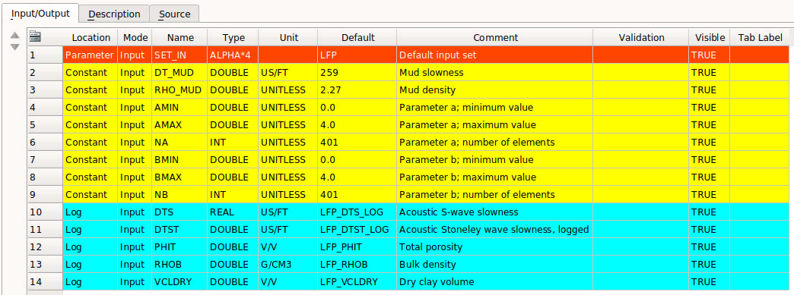

**A.2. Inversion source code**

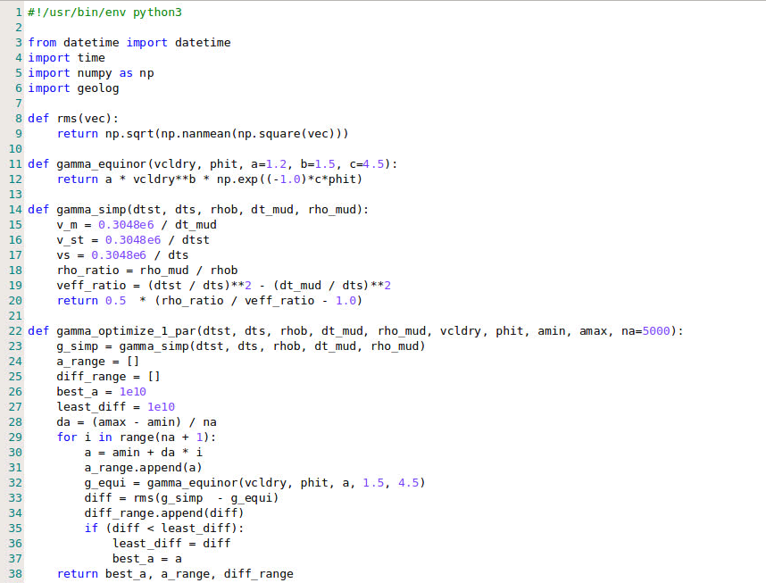  
  
  
  
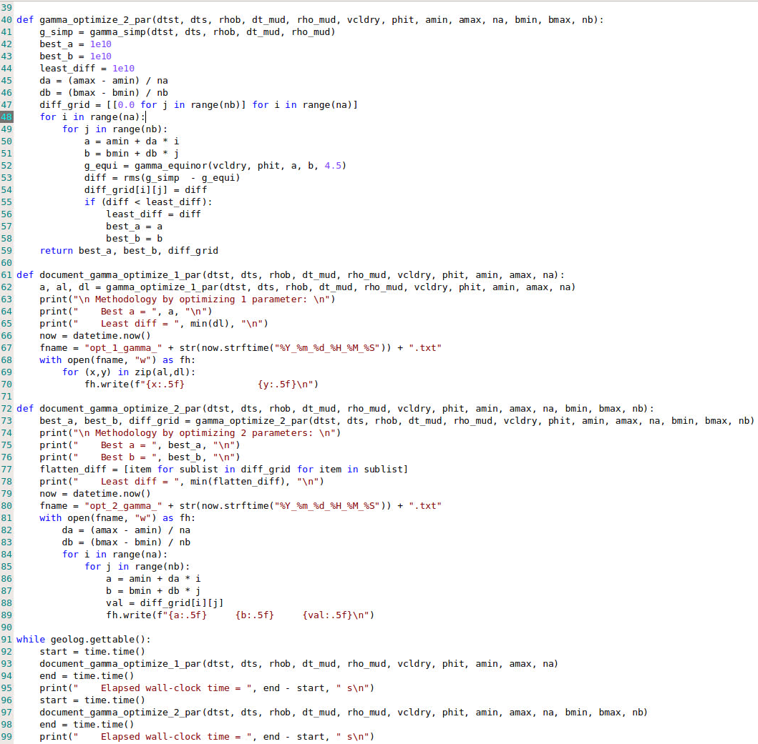

1. “Occam’s razor”, Wikipedia, <https://en.wikipedia.org/wiki/Occam%27s_razor>, accessed 02.03.2022.